

Programme Name: ________**BCS HONS**_______________________________________

Course Code: __**CSC 1403**________

Course Name: ________**Database concept**______________________________

**Individual Project**

Date of Submission: ______**9/24/2020**_____________

**Submitted By: Submitted To:**

Student Name**: Dipesh Tha Shrestha** Faculty Name**: Amar Subedi**

IUKL ID: **041902900028** Department**: LMS**

Semester**: Second Semester**

Intake**: September 2019**

**Table of Context**

1. Introduction
2. Requirement analysis
3. Database Design
4. ER diagram
5. SQl code for the database
6. Isuue and Problem
7. **Introduction**

Inventory management is one of the essential problems in almost every company. Before computer age and integration, solutions were used as inventory management tools. If there is no automated system available, these solutions may cause a lot of paperwork usually lead to mistakes as the workload increases since it deals with more than hundreds of medications. The company needs to use a new technology to keep track of all its transactions and day-to-day operations to achieve its business goals by introducing a computer-based Designing and Implementing such a system is possible but there is preliminary work studying the operational environment and needs of the company, identifying the requirements, determining software tools, designing database and developing the user interface application.

1. **REQUIREMENT ANALYSIS**

Requirement Collection and Analysis During this phase, the database designers meet potential system users to understand and document their data requirements. The result of this step is a briefly written set of users’ requirements . Knowing the requirements and needs of the system is vital to its success. Important inventory documents are collected and analyzed, including sale and purchase invoices, customers and suppliers’ records, employees' records, medicines’ records and customer payments. The collected requirements associated with this system include:

1. Drugs have expiration dates after which they may no longer be used. After a specific amount of time, the chemical structures of medications may change to reduce their strength or change it into a completely different product. Medications must be dragged off the shelf when this date approaches, because it is unsafe to distribute drugs after the expiration date has passed. It is important to consider expiration dates when ordering medications.
2. When preparing a sell invoice, it is important to use older medications before newer medications to ensure that products with shorter expiration dates are used before those that will last longer and minimize the number of expiring products.

3. Outdated products should be pulled off of the shelves at steady intervals to reduce the chance of expired medications getting to a patient.

4. Pharmacies can return medications that has been ordered in surplus or is moving slowly off of the shelves. In general, if a package has been unlocked or damaged and does not expire for at least 12 months, a company can accept the medication for return.

5. If any medications are received damaged or expired, or if the pharmacy accidentally ordered a product it does not need, it may be desirable for return to the company

**3. Database Design**

* **Employee**

|  |
| --- |
| **Employee** |
| ID |
| Name |
| Address |
| Contact |
| Role |
| Salary |

* **Customer**

|  |
| --- |
| Customer |
| Name |
| Contact |
| Address |
| Email |

* **Sale_Invoice**

|  |
| --- |
| Sale_InvoiceID(PK) |
| Date |
| TotalAmount |
| Payment Type |
| Discount |
| Payed Amount |
| RemainingAmount |

* **Purchase_Invoice**

|  |
| --- |
| Purchase_InvoiceID(PK) |
| Date |
| TotalAmount |
| Payment Type |
| Discount |
| Payed Amount |
| RemainingAmount |

* **Supplier**

|  |
| --- |
| Supplier |
| SupplierID |
| CompanyName |
| Contact |
| Adresss |

* Drug

|  |
| --- |
| Drug |
| Drugname |
| ScientificName |
| DrugCategory |
| No_of_unit_in_Package |
| Manufacturer |
| UnitPrice |
| StorageLOcation |

**E-R diagram**

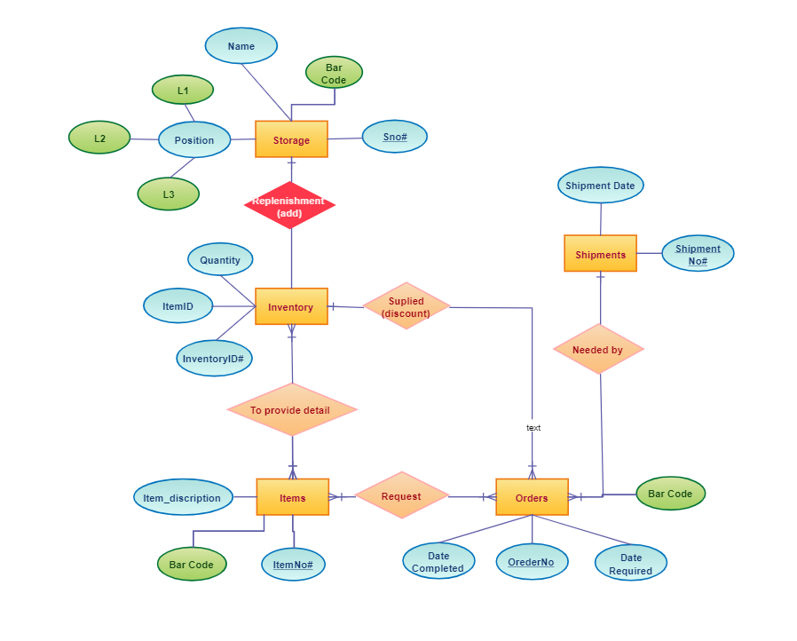**Fig: ER diagram of Inventory Management System**

SQl code for the database

6. **Problem faced while creating database**

Designing E-R diagram.